NAMRIA PageNET Management System

USER’S MANUAL



Geospatial Systems Development Division

Geospatial Information System Management Branch

TABLE OF CONTENTS

1. INTRODUCTION ………………………………………………………………………………………………………………..3
2. How to launch the NAMRIA PageNET Management System……………………………………………….3
3. How to use Scheduler…………………………………………………………………………………………………………4
4. How to use MANUAL DOWNLOAD……………………………………………………………………………………..5
5. How to use STATION LIST……………………………………………………………………………………………………9
6. How to use FILE SERVER……………………………………………………………………………………………………12
7. How to use RINEX SERVER………………………………………………………………………………………………..13
8. How to use TECQ Arguments……………………………………………………………………………………………14

## INTRODUCTION

The NAMRIA PageNET Management System is an integrated system that perform functionalities or features that was lacking in the LEICA System. The PMS will not replace the LEICA System but rather complement the system. The PageNET Management System was solely conceptualized to automate the Data Completeness Monitoring. The Data Completeness Monitoring is the monitoring of availability of files, Raw and RINEX data, generated by each AGS.

## How to Launch the NAMRIA PageNET Management System

1. Double Click on the Icon **PageNET Management System** on the Desktop. The Landing page (figure 1) will appear.

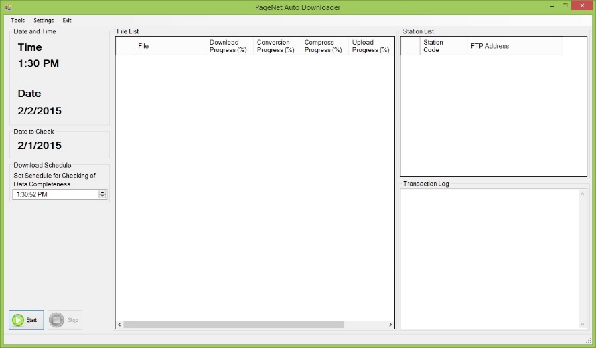

Status Bar

Transaction Log

Station List

File List

Start and Stop Buttons

Time Schedule

Date to Check

Computer Date and Time

File Menu

Figure I

The following are the sections in Figure I

* File Menu – shows menu to access other features.
* Computer Date and Time – Shows the Computer Date and Time.
* Date to Check – Shows the Date which the NAMRIA PageNET Management System will check for Data completeness.
* Time Schedule – Shows the Time which the NAMRIA PageNET Management System will check for Data completeness.
* Start and Stop Buttons – Starts and Stops the Scheduler.
* Status Bar – Shows the current process the NAMRIA PageNET Management System is processing.
* File List – Shows file(s) are missing from the File server and need to be processed.
* Transaction Log – Shows all Logs of the NAMRIA PageNET Management System activities.
* Station List – Shows all Stations.

## How to use SCHEDULER

IMPORTANT NOTE

Make sure that there are Stations present in the Station List and locations of the File Server and RINEX Server are present as well as TecQ Arguments. For more information on how to Setup Stations, please click this LINK. For more information on how to setup File Server, please click this LINK. For more information on how to setup RINEX Server, please click this LINK. For more information on how to setup TecQ Arguments, please click this LINK.

**To Start the Scheduler**

1. Set the Time the NAMRIA PageNET Management System will start to check for Data Completeness. (see Figure II) Please do note that some features of the program will not be accessible once the Scheduler has started.

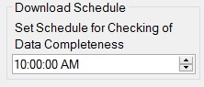

Figure II

1. Click Start Button to Enable the Scheduler (see Figure III) or Click Start on the Tools Menu. (see Figure IV)

 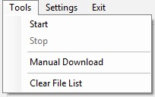

Figure III Figure IV

**To Stop the Scheduler**

1. To Stop the Scheduler, Click Stop Button to Disable the Scheduler (see Figure V) or Click Stop on the Tools Menu. (See Figure VI)

 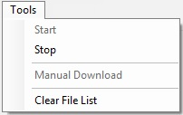

Figure V Figure VI

## How to use MANUAL DOWNLOAD

The **Manual Download** form is for downloading Data that must be downloaded and processed immediately or Downloading and processing older data.

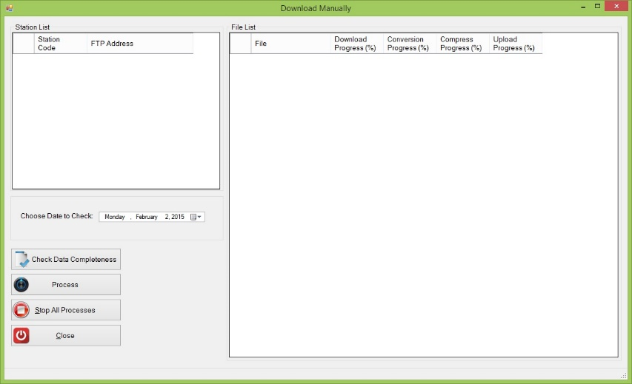

6

5

4

7

3

2

1

Figure VII

The following are the sections in Figure VII:

1. Station List – Shows all Stations.
2. Date to Check – Shows the Date which the NAMRIA PageNET Management System will check for Data completeness.
3. Check Data Completeness Button – Function to Initiate Data Checking.
4. Process Button – Function to Initiate Download/Convert/Compress/Upload of the selected file.
5. Stop All Processes Button – Function to Stop all Download/Convert/Compress/Upload of all the files.
6. Close Button – Closes the **Manual Download** form.
7. File List – Shows file(s) are missing from the File server and need to be processed.

IMPORTANT NOTE

Make sure that there are Stations present in the Station List and locations of the File Server and RINEX Server are present as well as TecQ Arguments. For more information on how to Setup Stations, please refer to **How to use Station List**. For more information on how to setup File Server, please refer to **How to use File Server**. For more information on how to setup RINEX Server, please refer to **How to use RINEX Server**. For more information on how to setup TecQ Arguments, please refer to **How to use TeqC Arguments**.

1. Click Tools Menu which is found under File Menu. Click **MANUAL DOWNLOAD** on the Tools Menu**.** (seeFigureVII) This will open up the **MANUAL DOWNLOAD** Form.

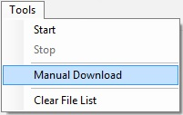

Figure VII

1. Select/Click a Station on the Station List. (see Figure VIII)

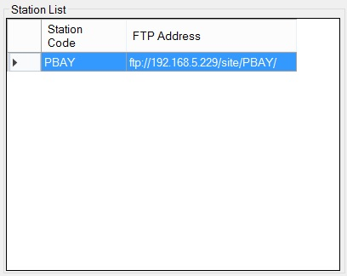

Figure VIII

1. Select a Date to Check. (see Figure IX)

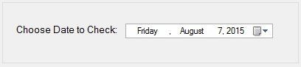

Figure IX

1. Click Check Data Completeness to Initiate Data Checking. (see Figure X)



Figure X

If there are Data missing, the missing files and unfinished downloaded files will be listed on the File List. (see Figure XI)

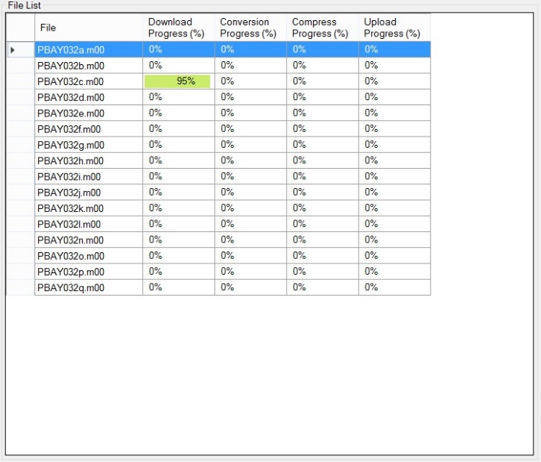

Figure XI

If there are no missing Data, a message prompt will appear saying that all files are downloaded. (see Figure XII)

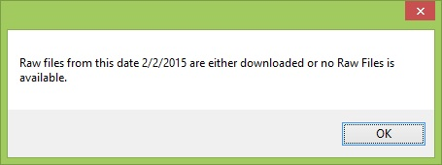

Figure XII

If connection to site did not succeed due to connection problems, a message prompt will appear saying that connection to site not established. (see Figure XIII)

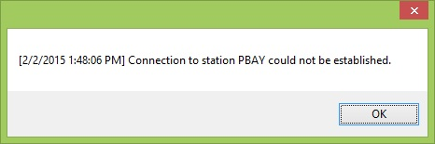

Figure XIII

1. To start Processing a File, Click **Process** button(see Figure XIV)or alternatively, select a file in the file list. Once selected, right click on the selected file and click **Process** (see Figure XV)from the Pop up Menu.



Figure XIV



Figure XV

1. To Stop All Processes, Click **Stop All Processes** button. (see Figure XVI)



Figure XVI

1. To Close **Manual Download** Form, Click **Close** Button. (see Figure XVII)



Figure XVII

## How to use STATION LIST

The **Station List** is for adding Stations/Sites that the NAMRIA PageNET Management System will check for Data Completeness.

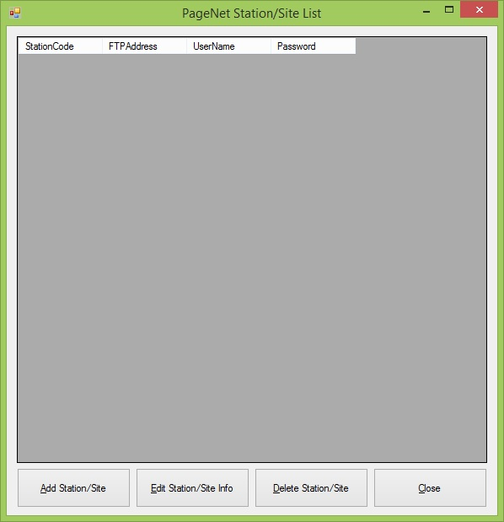

Figure XVIII

To access **Station List,** click **Settings** Menu which is found under File Menu. Click **Station List** on the Tools Menu**.** (seeFigure **XIX**) This will open up the **Station List** Form.

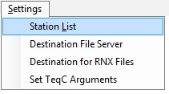

Figure XIX

**To Add Stations/Sites**

1. Click **Add Station/Site** button. This will open up the **Add Station/Site** Form. (see Figure XX)



Figure XX

1. Please enter all necessary Information on the **Add Station/Site** Form. Station Code only accepts up to 4 character code(i.e. PSUR), IP Address accepts up to 255 alpha numeric characters, User Name accepts up to 100 alpha numeric characters, and Password accepts up to 100 alpha numeric characters.
2. Click **Save** button to save. A message box will appear to notify the user that adding of station is successful. (see Figure XXI)

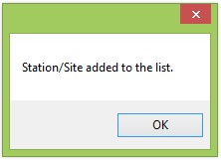

Figure XXI

**To Edit Stations/Sites Information**

1. Click **Edit Station/Site** **Info** button. This will open up the **Edit Station/Site** **Info** Form. (see Figure XXIII)



Figure XXIII

1. Please enter all necessary Information on the **Edit Station/Site** **Info** Form. Station Code only accepts up to 4 character code(i.e. PSUR), IP Address accepts up to 255 alpha numeric characters, User Name accepts up to 100 alpha numeric characters, and Password accepts up to 100 alpha numeric characters.
2. Click **Save** button to save. A message box will appear to notify the user that adding of station is successful. (see Figure XXIV)

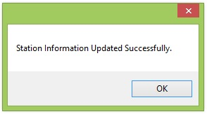

Figure XXIV

**To Delete Stations/Sites Information**

1. Select a row in the Station List. (see Figure XXV)

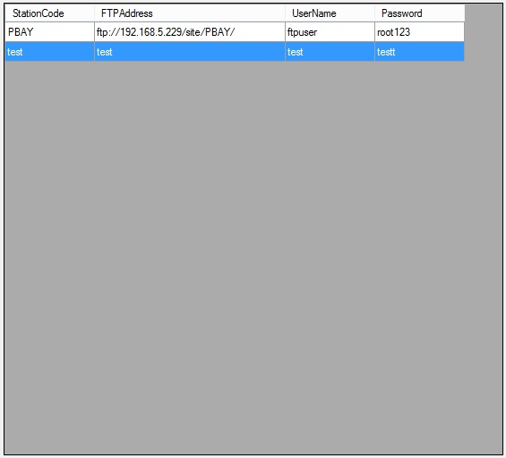

Figure XXVI

1. Click **Delete Station/Site** button. A message box will appear informing the user that Station/Site deleted successfully. (see Figure XXVII)

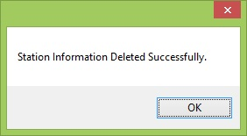

Figure XXVII

## How to use FILE SERVER

The **File Server** is for defining the location on where the application will store the processed Data Files.

1. Click **Settings** Menu which is found under File Menu. Click **File Server** on the Settings Menu**.** (seeFigureXXVIII) This will open up the **File Server** Form. (see Figure XXIX)

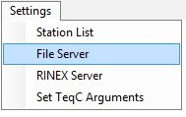

Figure XXVIII

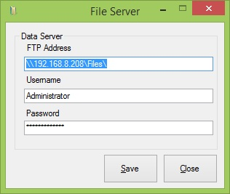

Figure XXIX

1. Please enter all necessary Information on the **File Server** Form. FTP address only accepts up to 255 alpha numeric characters (i.e. ftp://xxx.xxx.xxx.xxx/folder/, C:\SampleFolder), User Name accepts up to 255 alpha numeric characters, and Password accepts up to 255 alpha numeric characters.
2. Click **Save** button to save. A message box will appear informing the user that File Server Update is successful. (see Figure XXX)

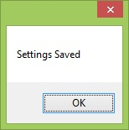

Figure XXX

## How to use RINEX Server

The **File Server** is for defining the location on where the application will store the processed RINEX Data Files.

1. Click **Settings** Menu which is found under File Menu. Click **RINEX Server** on the Settings Menu**.** (seeFigureXXXI) This will open up the **RINEX Server** Form. (see Figure XXXII)

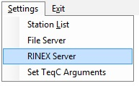

Figure XXXI

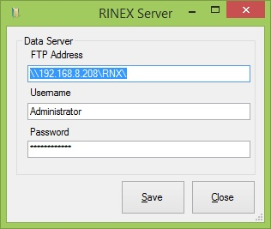

Figure XXXII

1. Please enter all necessary Information on the **RINEX Server** Form. FTP address only accepts up to 255 alpha numeric characters (i.e. ftp://xxx.xxx.xxx.xxx/folder/, C:\SampleFolder), User Name accepts up to 255 alpha numeric characters, and Password accepts up to 255 alpha numeric characters.
2. Click **Save** button to save. A message box will appear informing the user that RINEX Server Update is successful. (see Figure XXXIII)



Figure XXXIII

## How to use SET TEQC ARGUMENTS

The **Set** **TEQC Arguments** is for defining TeqC Arguments which will be used to convert the downloaded Data files into RINEX Files.

1. Click **Settings** Menu which is found under File Menu. Click **Set TeqC Arguments** on the Settings Menu**.** (seeFigureXXIV) This will open up the **Set TeqC Arguments** Form. (see Figure XXXV)

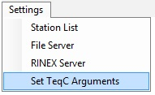

Figure XXXIV

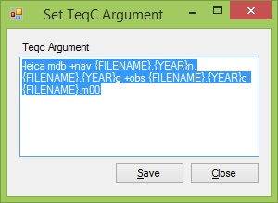

Figure XXXV

1. Please enter all necessary Information on the **Set TeqC Arguments** Form. **Teqc Argument** only accepts up to 3000 alpha numeric characters.
2. Click **Save** button to save. A message box will appear informing the user that **Set TeqC Arguments** Update is successful. (see Figure XXXVI)



Figure XXXVI